Lab 4
Title:
Study and Implementation of Switch, Break, and Continue Statements in C++
Objective:
To understand and implement decision-making and loop control statements using switch, break, and continue in C++.
Theory:
Switch Statement:
The switch statement is used for multi-way decision making. It allows a variable to be tested against multiple values (cases).
Syntax:
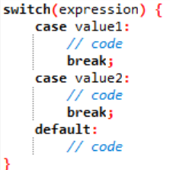
Break Statemen:
The break statement is used to:
- Exit from a switch statement
- Terminate loops (for, while, do-while)
- Without break, execution continues to the next case (called fall-through).
Continue Statement:
The continue statement is used in loops to:
- Skip the current iteration
- Move to the next iteration of the loop
Programs
Program 1:
Switch Statement
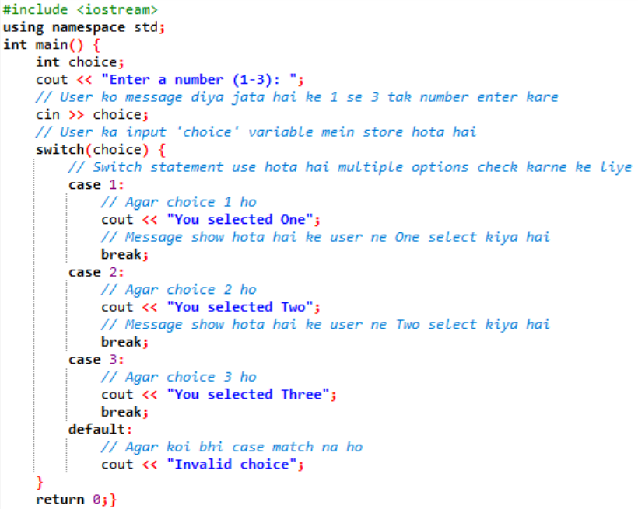
Program 2:
Break Statement in Loop:
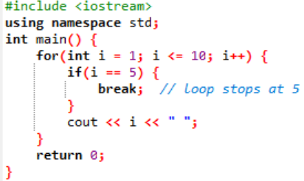

Program 3:
Continue Statement in Loop:
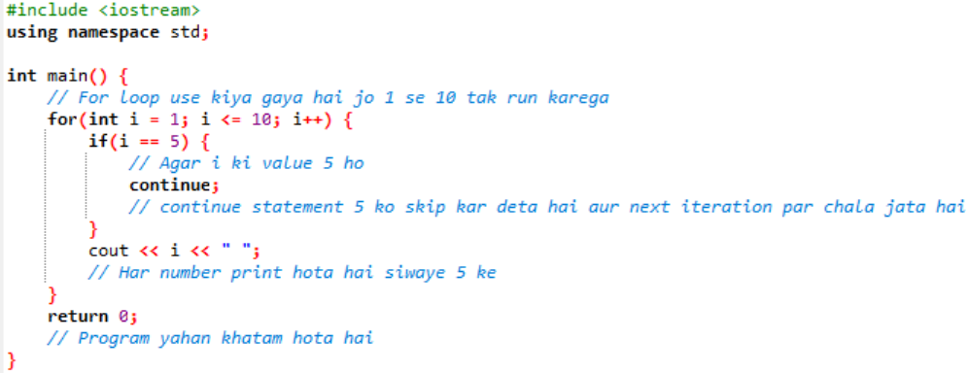

Conclusion:
- The switch statement simplifies multiple condition checking.
- The break statement is used to exit loops or switch cases.
- The continue statement skips an iteration and continues the loop.
- These statements improve program control and efficiency.

Lab Tasks
1: Write a C++ program that takes an input of a day’s number and uses a switch statement to output the corresponding day’s name. Here’s how the program will proceed
- The program prompts the user to enter the day’s number.
- The user enters a number between 1 and 7, where 1 is Monday and 7 is Sunda
- The program uses a switch statement to check which day was entered.
- Depending on the entered number, the corresponding day’s name is outputted
- using the cout statement.
- The break statement is used to end each case statement and prevent the program
from executing subsequent case statements.
- Finally, the program returns 0 to indicate successful execution
Code:
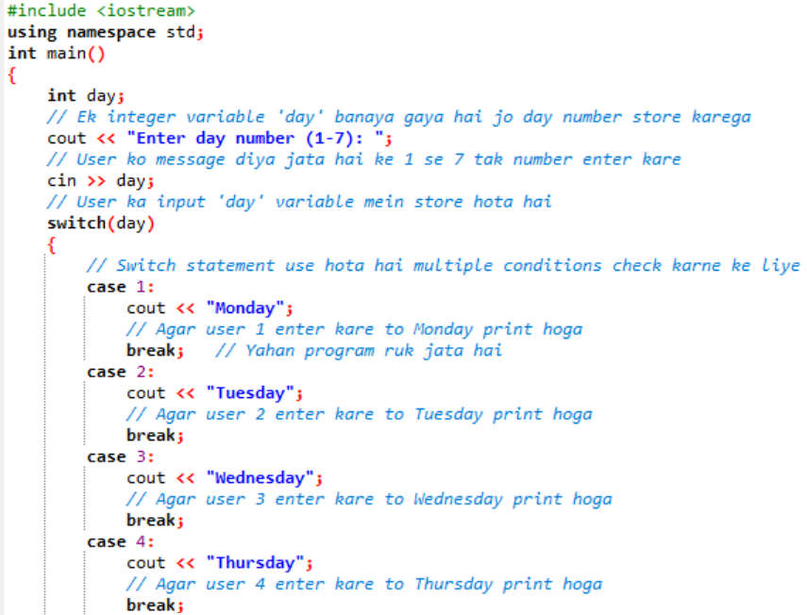
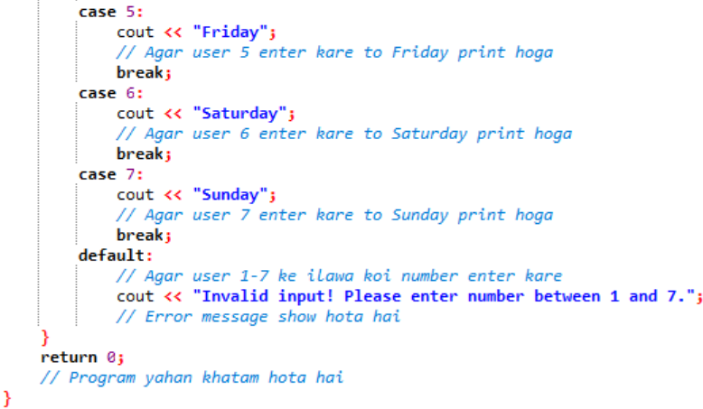
2: Write a C++ program using switch that takes a character grade (A, B, C, D, F) from the user and
prints
- A → Excellent
- B → Very Good
- C → Good
- D → Pass
- F → Fail
- If any other character is entered, display "Invalid Grade".
Code:
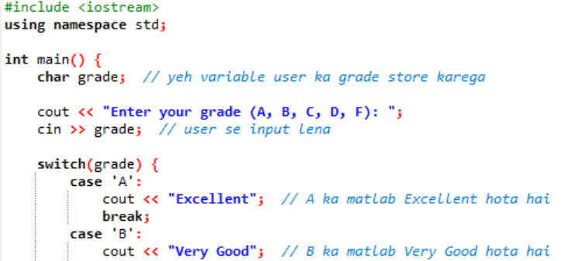
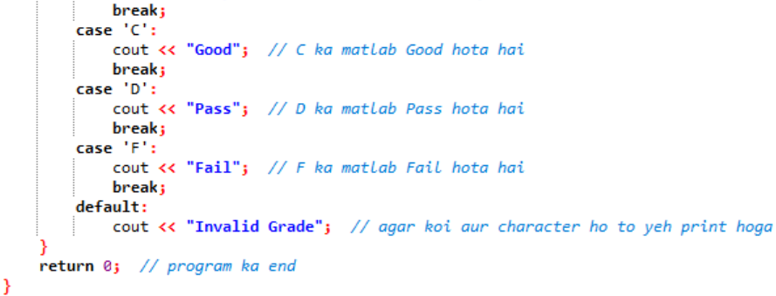

3: Write a C++ program using switch that displays the following menu
- 1 → Convert Kilometers to Meters
- 2 → Convert Meters to Centimeters
- 3 → Convert Kilograms to Grams
- 4 → Convert Celsius to Fahrenheit
- The program should:
- Take user choice
- Ask for input value
- Perform the selected conversion
- Display the result
- Show "Invalid choice" if input is wrong
Code
